Spartina Mapping - Saving & Naming Waypoints
1) Hold the GPS antenna/receiver above your head while standing still to get the best satellite reception.
2) Save a waypoint using averaging (30 to 60 counts/seconds) to improve position accuracy
3) Rename each waypoint as follows: A waypoint will have 5 digits
- first 3 digits are determined by the GPS (range 001 to 999). The GPS will not let you save two waypoints with the same name.
- 4th digit = the size class of the plant
- 5th digit = the species of Spartina

Size Class Codes:
S = seedling or single plant | 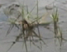
A = small "clone" or plant cluster less than 0.3m diameter | 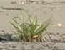
B = clone 0.3m to 1.0m diameter  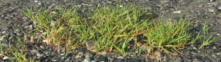 | 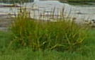
C = clone larger than 1.0m diameter | 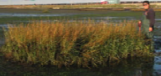
D = cluster of seedlings in an area approx. 5m in diameter | 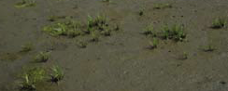
M = center of a large area (>5m) with too many Spartina clones or plants to map individually. Indicate the extent of the area with more “M” points or the track technique on the perimeter. Include a text note with the data to describing what you did. | 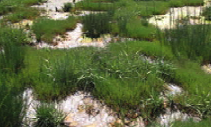

Spartina Codes:
1 = Spartina anglica 2 = Spartina densiflora
3 = Spartina patens 4 = Spartina alterniflora

Examples of renamed waypoints:
067B1 = a S. anglica clone, diameter 0.3m to 1.0m
003Z1 = stopped searching for S. anglica here
798S2 = seedling of S. densiflora

The Excel template file for submitting your GPS data can be found at http://spartina.ca. The site includes other aids for identifying Spartina sp.

Mapping Removed Plants:
R = seedling or clone removed by hand
Y = Spartina burial site (excavator buries clones under 2m of sediment.
X= extent of larger area of plant removal. (same directions as “M” points)

Searching:
Z = extent of your search area - start & end points along a shore or the corners of the area of mud flat searched - even if Spartina was not found.

It is very important to know where volunteers have search and not found Spartina sp. You can also use the track technique when searching. Include a short text note with your data to help us interpret your search waypoints.

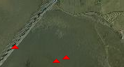
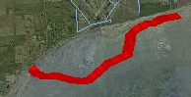
Recording GPS Tracks:
You can save a "track" in you GPS of the outer perimeter of the area you have searched and submit it with a text file explaining what you did. This "track" technique can be used in place of a series of points captured to define an area as in the "M", "X", "Z" codes. Using the “track” technique reduces the data entering time by avoiding point averaging but requires that you keep moving. If you stop moving during a track you may gather too many points in one location. Some GPS receivers support setting the track recording based on distance moved. This is a good technique that allows you to stop walking for short periods without collecting extra track points. If you use the distance moved option, set to a value of 10m, which will give the best results without collecting extraneous points.

